Week6_Creating Your First React Application (myfirstreact)

Objective: To set up a React development environment and create a simple React application that displays a welcome message.

Phase 1: Setting Up Your Development Environment
Step 1: Install Node.js and npm
- Explanation: Node.js is a JavaScript runtime that lets you run JavaScript on your computer. npm is the package manager for Node.js, used to install and manage project dependencies like React.
- Action:
- Open a web browser and navigate to the official Node.js download page: https://nodejs.org/en/download/
Step 2: Install Visual Studio Code
- Explanation: Visual Studio Code (VS Code) is a free, powerful code editor that is highly recommended for React development.
- Action:
- Go to the official VS Code website: https://code.visualstudio.com/
- Download and run the installer for your operating system.
Step 3: Install create-react-app
- Explanation: create-react-app is a command-line tool that allows you to create a new React application with a pre-configured setup. This saves you from the complex task of manually setting up a modern React development environment. The -g flag in the command installs the package globally on your system, so you can use it from any directory.
- Action:
- Open your command prompt (on Windows) or terminal (on macOS or Linux).
- Type the following command:
npm install -g create-react-app

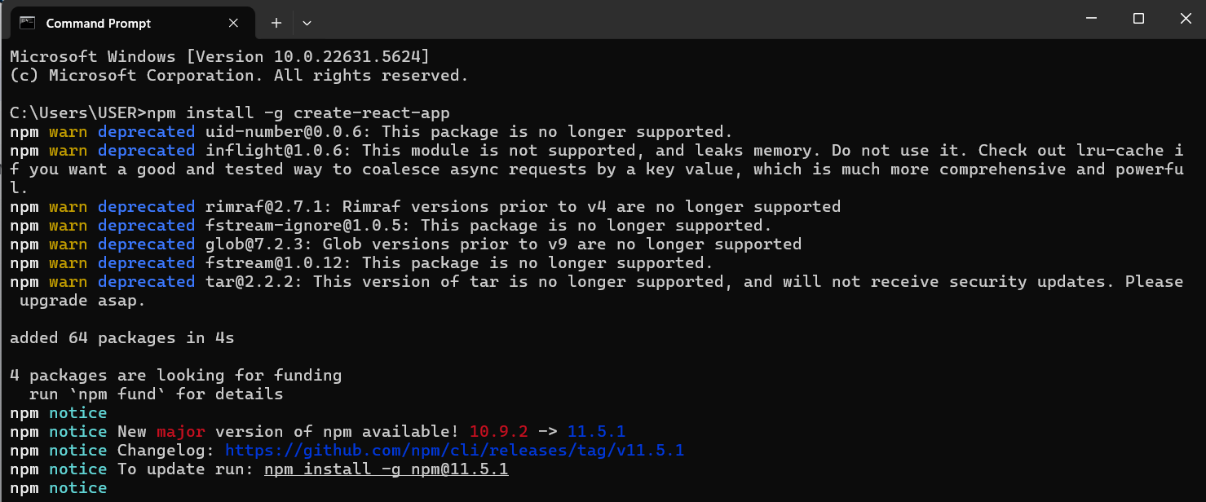

Phase 2: Creating and Running the React Application
Step 4: Create the React Application
- In your command prompt or terminal, navigate to the directory where you want to store your project (e.g., your Desktop or a development folder).
- Type the following command and press Enter. This may take a few minutes to complete.
create-react-app myfirstreact

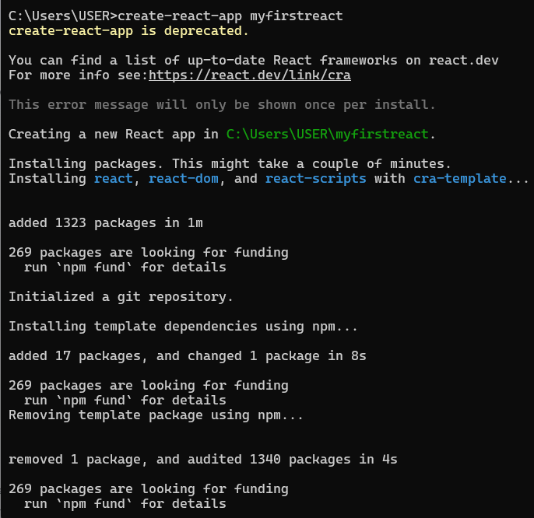
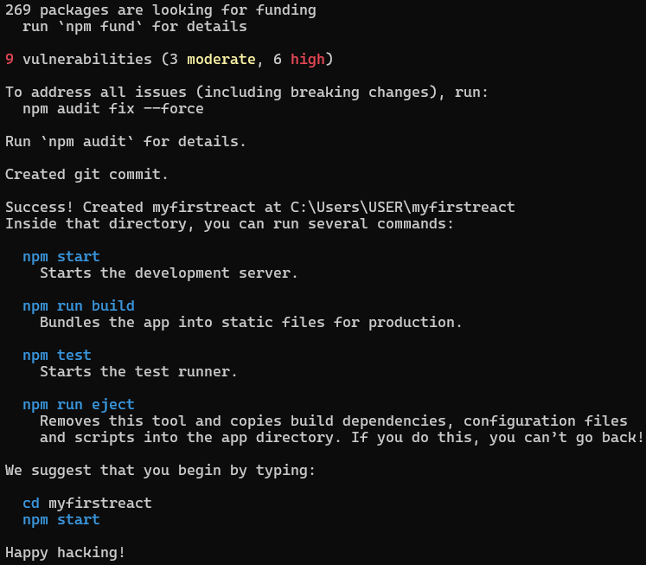
Step 5: Navigate into Your New Project Folder
- You must be inside the project folder to run commands related to this specific application.
- Once the command from Step 4 is finished, type the following command to move into the newly created directory:
cd myfirstreact
Step 6: Open the Project in Visual Studio Code
- This command opens the entire project folder in VS Code, allowing you to easily browse and edit the project files.
- While in the myfirstreact folder in your command prompt or terminal,
- Type the command:
code .
Note: The . tells VS Code to open the current directory.
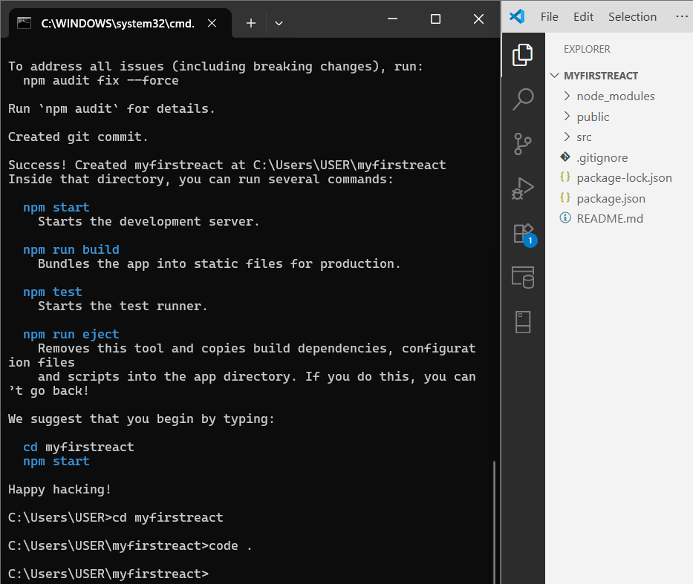
Step 7: Edit the App.js Component
- The App.js file is the main component of your application. We will modify it to change what is displayed on the screen.
- In Visual Studio Code, locate the file explorer on the left-hand side.
- Expand the src folder.
- Click on the App.js file to open it in the editor.
- Delete all the existing code within App.js.
import React from 'react';import './App.css';
function App() {
return (
<div className="App">
<h1>welcome to the first session of React</h1>
</div>
);
}
export default App;
Step 8: Run the Application
- This command starts the development server, which builds your application and makes it available in a web browser. The server will also automatically reload the page whenever you save a file.
- Return to your command prompt or terminal (which should still be in the myfirstreact directory).
- Type the following command and press Enter:
npm start

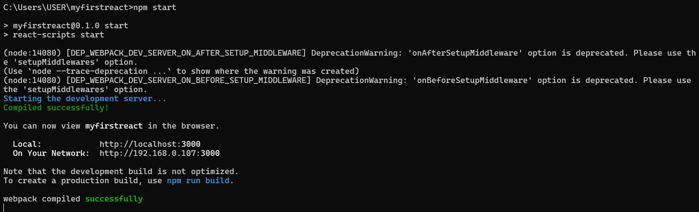
Step 9: View Your Application
- The development server hosts your application on a local port, typically 3000.
http://localhost:3000. (or) http://192.168.0.107:3000

Output:
